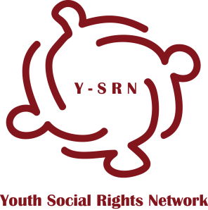
Membership Application
To join Youth Social Rights Network
- If you have questions completing this application form email to ysrnetwork@gmail.com

Application Submission date:

Section 1 Organization/Individual Details
Name of the Organization/Individual:
Country of Registration/Nationality:
Date of Registration/Birth:
Register Entry Number:
Official Address:
Email Address:
Telephone Number:
Web:
Skype ID:

Section 2 Organization Representative
The organization representative is a person designated as official representative of the organization in Youth Social Rights Network. Organizations that are youth led and are applying for full membership need to select YOUNG person to represent them in Y-SRN. Organizations that are applying for partners and supporters type of membership are also strongly encouraged to send youth representatives if applicable.
Name:
Age:
Position:
Address:
Email Address:
Telephone Number:

Please describe your representative’s role in the organization and the person’s professional background.

Section 3 Experience of the Organization/Individual
- Please provide a brief summary of the organizations programs, services and activities that are targeted toward young people and if and how your organization plans to become more youth oriented.
- In the case of individual application describe your experience toward working with or for young people

Section 4 Network Membership
How do you plan to contribute to Youth Social Rights Network?

What motivated the organization/you to join Youth Social Rights Network?
Please indicate membership of any other network/association/organization

Section 5 Type of Membership
Please indicate type of membership you are applying for
- Full member
- Partner or supporter
Section 6 Additional Documentation
Please attach the following documents to the application form
- CV of the individual membership applicant or the designated representative of the organization
- Signature of a protocol of commitment to the network’s values and mission
- Additional documents for organizations:
- Letter representing organizations history and actions
- Statute
- Scan of Certification from the corresponding registry that accredits the composition of the organization’s Board, and register entry number

Application form for membership together with required additional documentation should be sent to ysrnetwork@gmail.com

